(GWA) GREAT WORLD ADVENTURE
Cuban Culture and Wellness Week
Explore the arts, architecture, culture and sustainable communities. With an additional focus on personal wellness through yoga, paddleboarding and other health related experiences

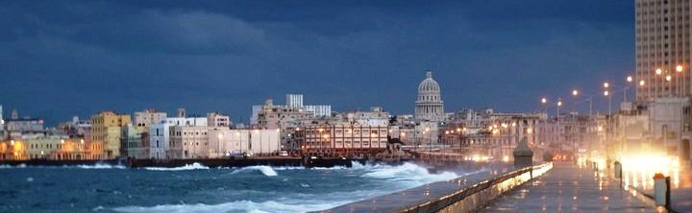
This program has the perfect combination of guided and independent experiences in both Urban and Rural settings. US citizens may be eligible under the “General License”, which is a do it yourself authorization, no further application is required.
Day One - Arrive in Varadero or Havana, transfer to hotel. Orientation, introduction and lessons on how to speak Spanish. Sunset paddle/yoga

Day Two – Morning paddle/yoga. Tour of Iglesia Santa Elvira (church) Varadero/Matanzas. Matanzas Municipal Art Gallery Tour International Health and Wellness Centre in Varadero. Spanish and dance lesson. Sunset paddle/yoga
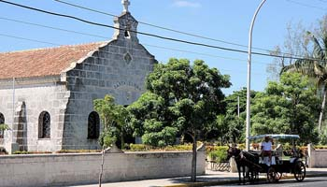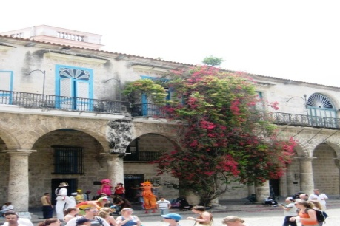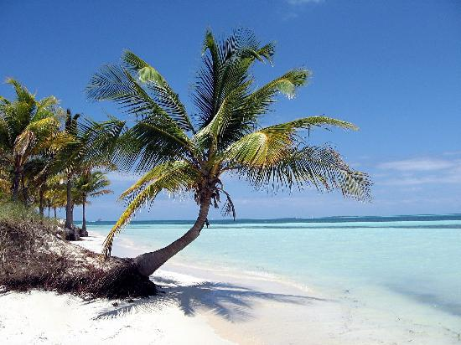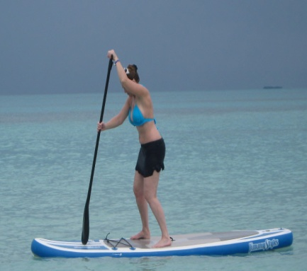
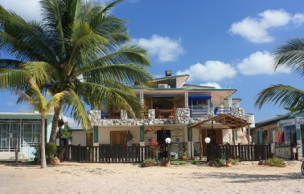
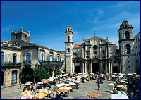
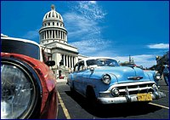
Day Three - Morning paddle/yoga. Historic and Cultural tour of Old Havana, Lunch at Parque Central rooftop or Hotel Saratoga. Afternoon, El Capitalo , Presentation on the Historian’s Office effects on Old Havana community restoration projects. Walk through the restored Cathedral Square, Plaza Vieja Square and Cathedral of Christopher Columbus enroute to the Maqueta de La Habana (scale model of the city), Ongoing presentation of Old Havana UNESCO sites Cruise the Malecon on the way out of Havana heading for Matanzas province
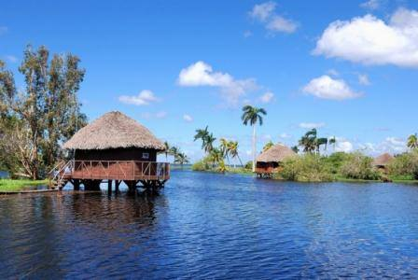
Day Four – Morning Paddle/yoga, Visit UNESCO designated site, Guama, Peninsulia de Zapata Bioreserve in La Laguna Treasury. It is a renovated historical outdoor museum complex that attempts to reconstruct the life of the Taintos. Access is by boat. It is a true work of art created by the renowned Cuban sculptor Rita Longa and has been admired by thousands of tourists who visit Guamá. Also visit Caleta Buena optional snorkeling available) a natural breakwater with many tropical fish swimming in plain view. Return to Varadero or Havana, evening

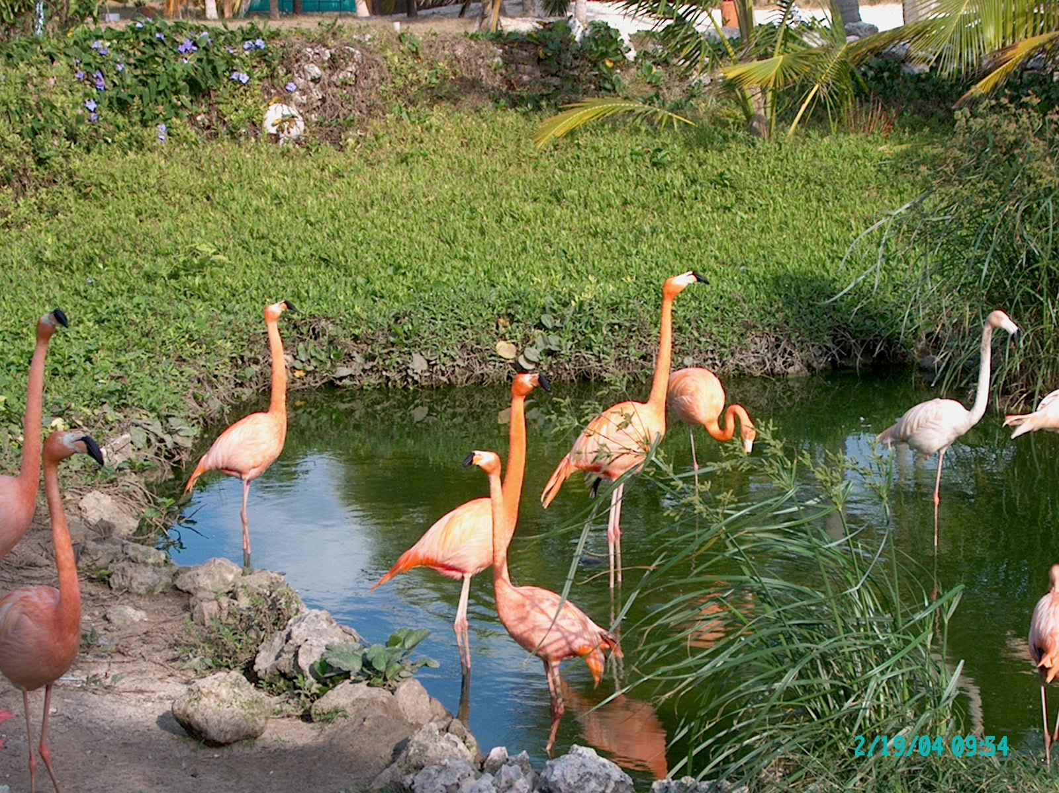
Day Five- Resume Spanish Lessons and explore Varahicacos Ecological Reserve: Considered the largest wetland reserve in the Caribbean, the Varahicacos ecological reserve offers breathtaking, low level hiking along vegetation-rich trails with colorful array of wild exotic birds which include parrots, Caribbean flamingos, Yellow-crowned Night-Heron and stalks

Day Six (Jan 20)
Matanzas Municipal Art Gallery (Matanzas Galeria de Arte Municipal). Tour International Health and Wellness Centre in Varadero. Sunset paddle/yoga

Day Seven - Depart

