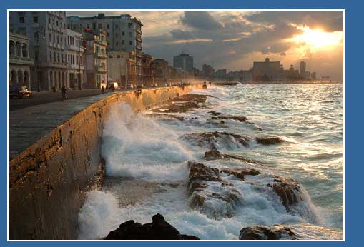

1st Annual International
Conference on Sustainable EduTourism
Explore the potential between Education/Cultural Activities and Sustainable Tourism

November 8 & 9, 2010
Melia Cohiba Hotel, Havana, Cuba

What does traveling to Las Vegas for a conference, to Italy to learn culinary skills, and to Havana for university study all have in common? They are examples of innovative ways of combining learning with traveling to unique locations. EduTourism can be described as travel for the purpose of formal or informal learning in a unique local environment. The result: a socially and economically sustainable tourism product that benefits both the region and its visitors.

This conference will explore the vast possibilities and benefits that exist in the alliance between the Education and Tourism/Hospitality sectors. Local destinations and travelers will benefit from these industries working collaboratively to promote the unique combination of a region’s tourism products with the region’s cultural and educational offerings.

Leading International Experts, within the Education and Tourism/Hospitality fields will provide insights, stimulate discussion, and facilitate capacity-building sessions on how to identify and move forward with creative EduTourism initiatives.

So, why EduTourism? The economics and demographics of travelers are changing rapidly. It is more critical than ever to respond proactively and develop new and sustainable education and tourism opportunities that better capitalize on these changes.

Conference Highlights

- Various high level networking opportunities to establish potential partnerships such as breakfasts, receptions, excursions, business matchmaking services and interactive workshops.

- Keynote addresses by K. Michael Haywood - President of the Haywood Group and an international industry expert specializing in the development of training programs on “enlightened hospitality” and the development of strategic approaches to developing sustainable tourism. And

- Information sessions and interactive workshops designed for developing an individual action plan for each participant to move toward creating a capacity building, sustainable EduTourism offering.

- Panel discussions involving all levels of government, the private sector and universities will explore specific issues that will be pertinent to all attendees.

Detailed Information on the Conference, Speaking and Sponsorship Opportunities:

www.edutourismconference.org or info@edutourismconference.org or 902.422.3483

